THE PRESENTATION TITLE (Calibri 14)

J. White¹, M. Black^{2,*} (Calibri 12)

¹ First Affiliation, Mail address, City, Post Code, Country (Calibri 10)
² Second Affiliation, Mail address, City, Post Code, Country
* Corresponding author: author@server.edu (Calibri 10)

Keywords: keyword 1, keyword 2, keyword 3, keyword 4 (Calibri 10)

The abstract should be written in English on an A4 paper size using the Calibri font, size 11 points and single line spacing. The abstract cannot exceed one page length. It should be formatted according to the provided template. The Abstract must be submitted using the ABSTRACT bookmark on the web page https://ambra.intibs.pl/ after registration and login. (Calibri 11)
The names of the authors, written in bold, should be with initials of first names only, followed by the last names in full. The names of the authors should be separated by commas. Underline the name of the presenting author and put an asterisk (*) after the name of the corresponding author. Numbers should appear after the author's surname. A figure can be inserted into the abstract text as jpg or tiff file of good quality. Figure caption must be italicized and should be put below the figure. References should be consecutively numbered in the text using square brackets [1] and listed by the numbers at the very bottom of the page as regular text (not inserted automatically, as offered by MS Word)
Leave one blank line after the title, list of authors, list of affiliations, keywords, and abstract text (before References). Do not insert indentation at the beginning of paragraphs. There should be one blank line above and below an equation.
Abstracts will be collected in the Book of Abstracts as submitted, without any editing. This is a solely responsibility of the Authors to prepare their abstracts according to this template. Name the abstract file using the first letter of the name and full second name of the corresponding author: J.White.docx.

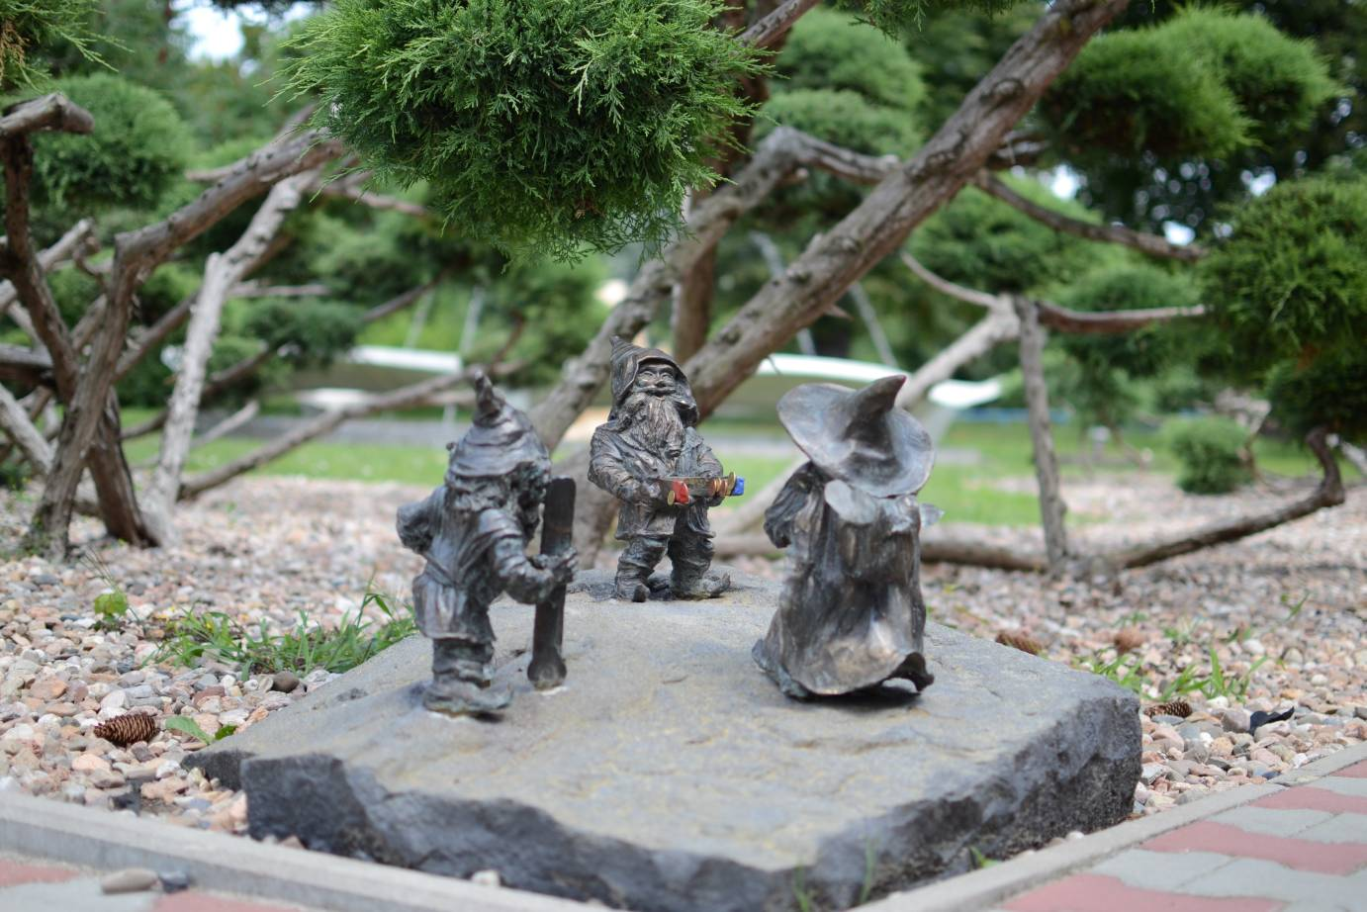
Fig. 1. Dwarfs in front of the Institute of Low Temperature and Structure Research PAS in Wrocław.

References
[1] J. Kowalski, J. Lumin. 150 (2008) 143.
[2] A. Nowak, J. Lumin. 180 (2012) 92.

